
Company
Logotype

Cone Beam Computed Tomography- Report



Porur Dental X-rays & CBCT

Patient Name : Miss. Mehar Babu | Date of Report : 19.04.2024
Age/ Gender : 20 years/ Female | Region of Interest : CBCT Maxilla
Referring doctor: Dr. Balamurali Sai | Indication : Impacted tooth
Clinical Notes: Nil
PATIENT INFORMATION

CBCT Maxilla provided
CBCT – IMAGE DETAILS

RADIOGRAPHIC INTERPRETATION

- Completely missing crown and root portion in relation to 27.
- The tooth 17 is horizontally placed and positioned such that its crown is positioned in posterior aspect. Its root portion is positioned in anterior aspect adjacent to the distal aspect of 16. The tooth 17 lies in contact with the floor of the right maxillary sinus.
- The tooth 16, 26 is present with hyperdense restorative material within the pulp canal and extends upto the apical third of the roots.
- The tooth 27 is positioned obliquely, such that crown is positioned in posterior aspect and the root is positioned in contact with the distobuccal and palatal root of 26.

RADIOGRAPHIC IMPRESSION


- Impacted teeth: 17, 27.
- Root canal treated teeth: 16, 26

IMAGES FOR REFERENCE

RECONSTRUCTED PANORAMIC VIEW
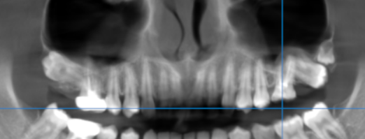
CROSS- SECTIONAL SECTION
Impacted 17 | 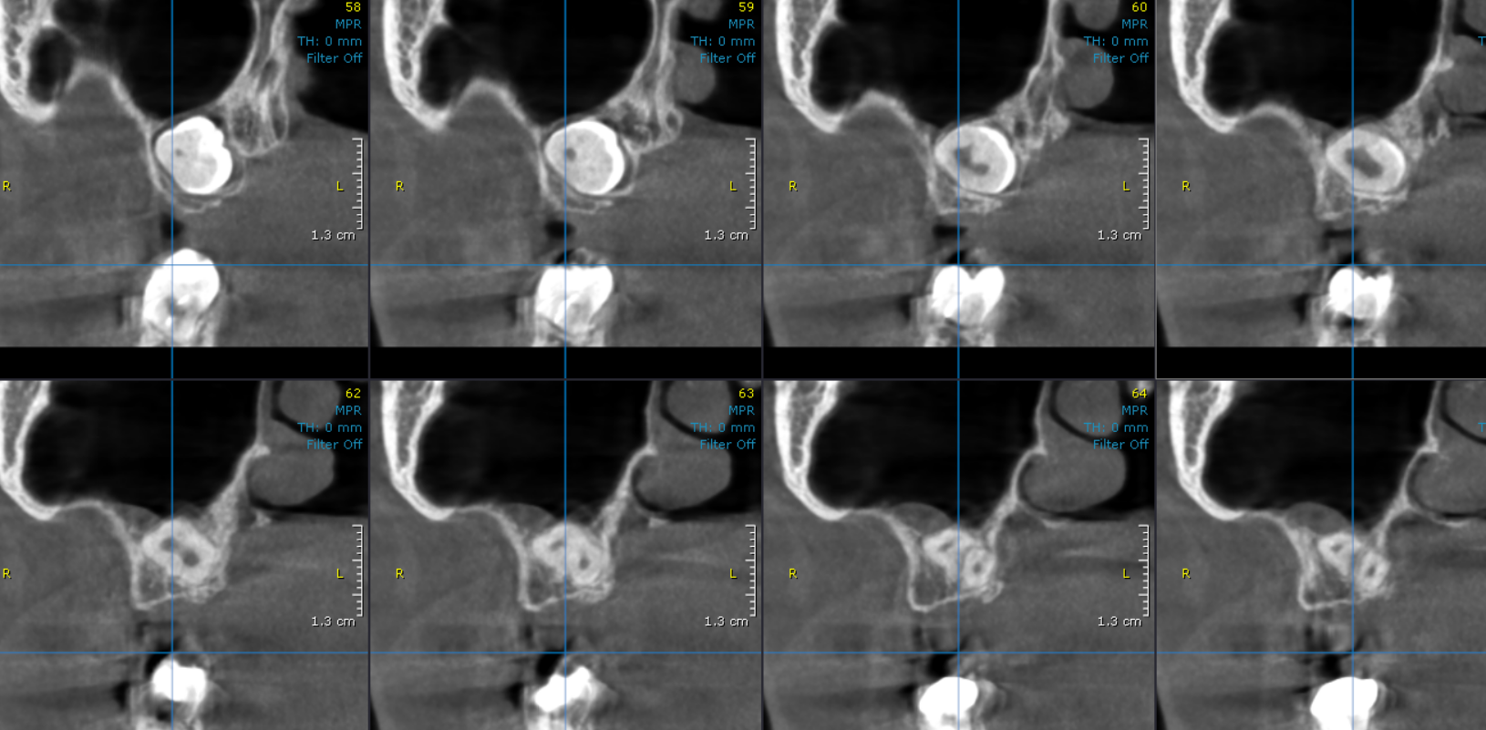
Impacted 27 | 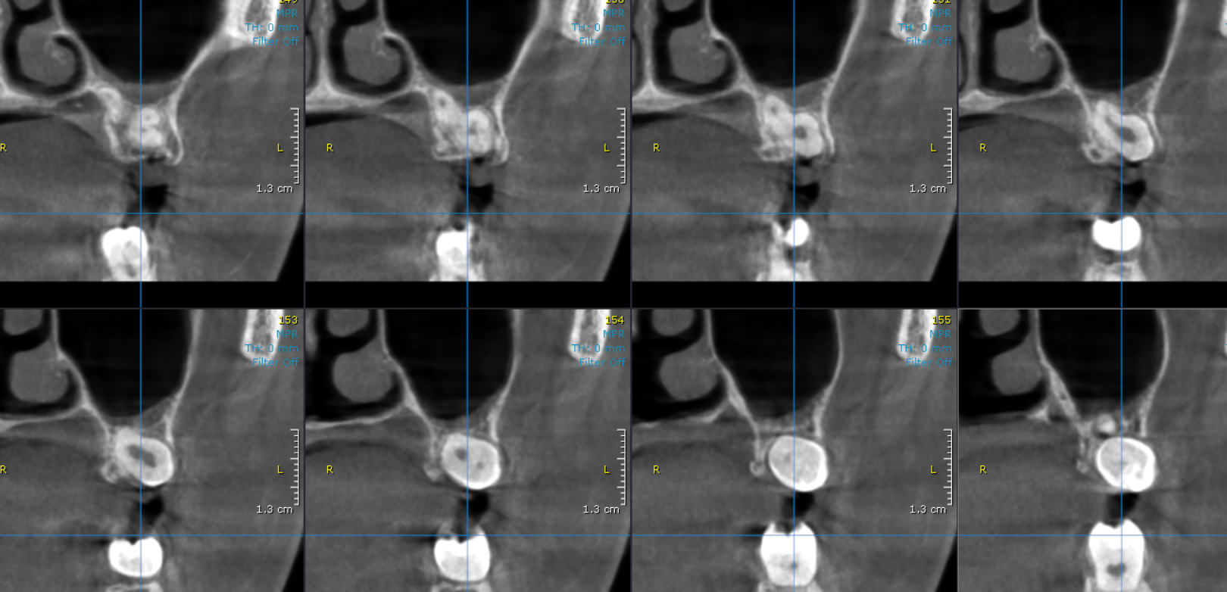

3-DIMENSIONAL VIEW

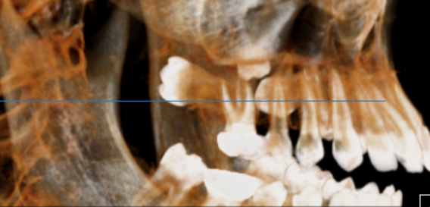

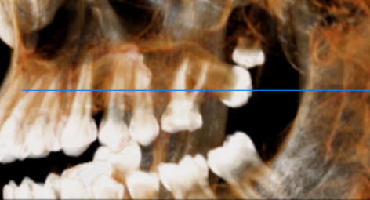

**** End of report ****

